East Hills Girls Technology
High School
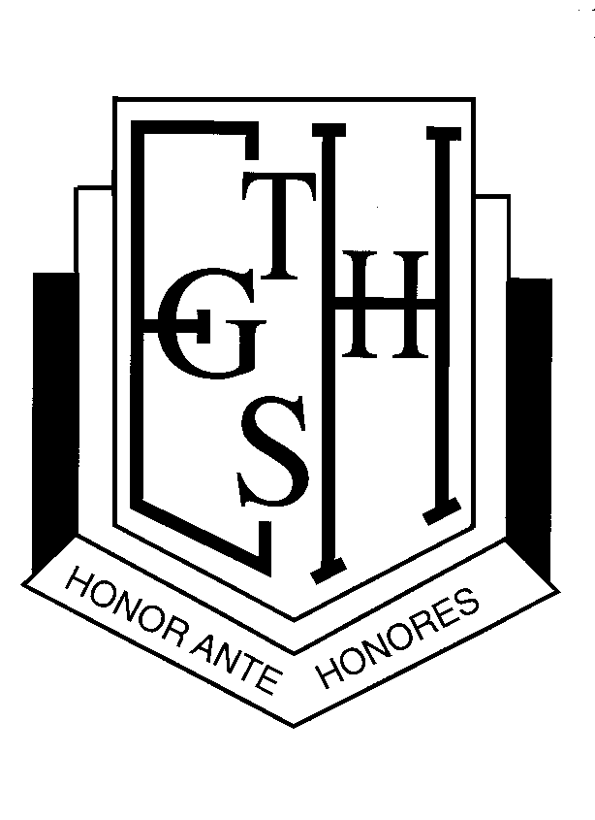
Phone: 9773 9160 Lucas Road, Panania, 2213
Fax: 9792 3853 PO Box 249, Panania, 2213
Email: easthillsg-h.school@det.nsw.edu.au

Principal – L. Andre

Special Religious Education (SRE) Participation Letter

Years 7, 8 and 9

A feature of the public education system in NSW is the opportunity to provide time in class for education in ethics, faith and morality from a religious or non-religious perspective at the choice of parents. The school website https://easthillsg-h.schools.nsw.gov.au/ provides information on these options to support parent/carer choice.

A parent/carer may at any time notify the school in writing that they wish to change their decision. Students will continue the same arrangement as the previous year, unless a parent/carer has requested a change in writing. For more information about Special Religious Education (SRE) including the list of approved providers, please visit: https://education.nsw.gov.au/teaching-and-learning/curriculum/learning-across-the-curriculum/religion-and-ethics

If your preferred SRE option is not available please contact the approved provider. The following options are available at East Hills Girls Technology High School. Please choose one.

SRE Options

Option 1: Christian Education Seminar - will be conducted by an authorised representative from the Baptist Union of NSW, which is an approved provider

Option 2: Islamic Education Seminar - will be conducted by an authorised Islamic representative of the Islamic Council of NSW, which is an approved provider

Please check this box if you do not wish for your child to attend SRE. Your child will participate in supervised alternative meaningful activities

Prayer Room - the school offers a room for students of Islamic faith to practise religious observance (prayers).

Please check this box if you give permission for your daughter to use the prayer room.

Student name: Year:

Signature of parent/carer: Date:

